Ryan Hatch

Project 2  
DAD 220  
SNHU

1. Begin by writing SQL commands to**capture usable data** (which you’ve preloaded into Codio)for your analysis.  
     
   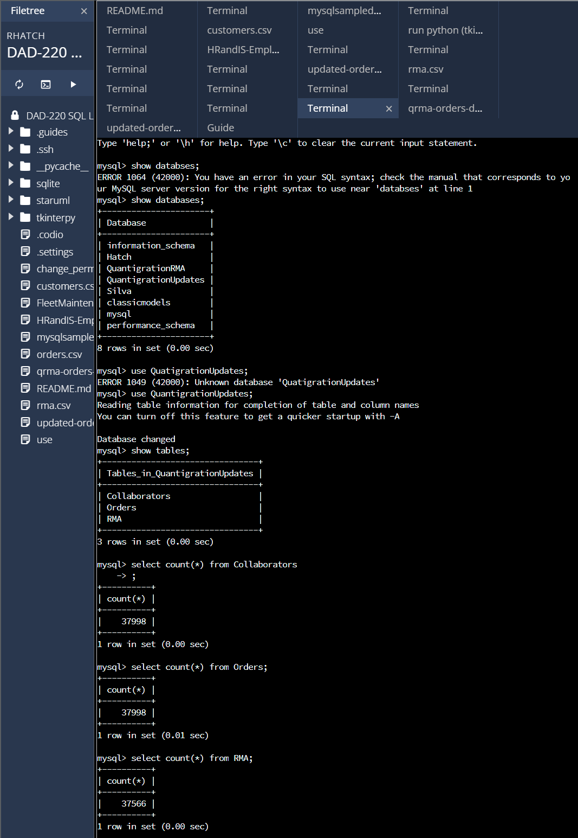

mysql> show databases;  
mysql> use QuantigrationUpdates;  
mysql> show tables;  
  
mysql> select count(*) from RMA;  
+----------+  
| count(*) |  
+----------+  
| 37566 |  
+----------+  
1 row in set (0.00 sec)

mysql> select count(*) from Collaborators;  
+----------+  
| count(*) |  
+----------+  
| 37998 |  
+----------+  
1 row in set (0.00 sec)

mysql> select count(*)  
from Orders;  
+----------+  
| count(*) |  
+----------+  
| 37998 |  
+----------+  
1 row in set (0.01 sec)

RMA Analysis:

In this report, we will summarize the data analysis of return merchandise authorizations (RMAs) for Quantigration and identify key information that will help streamline operations. Our analysis provides usable information for the product manager to make informed decisions and take actions to optimize operations and enhance customer satisfaction.

Analyze the number of returns by state and describe your findings in your report:

Analyzing returns by state allows the product manager to identify regions with higher return rates. This information helps pinpoint potential issues related to product quality, customer experience, or shipping logistics in specific states. By focusing on these regions, targeted strategies can be implemented to address the underlying causes and improve customer satisfaction. The top 10 states with the highest number of returns were Massachusetts, Arkansas, Oregon, West Virginia, Alabama, Connecticut, Idaho, Mississippi, Tennessee, and Delaware. By allocating resources effectively and implementing quality control measures, the product manager can mitigate returns and improve customer support in these areas.

1. Specifically, the product manager wants you to analyze the following: (25%)  
     
   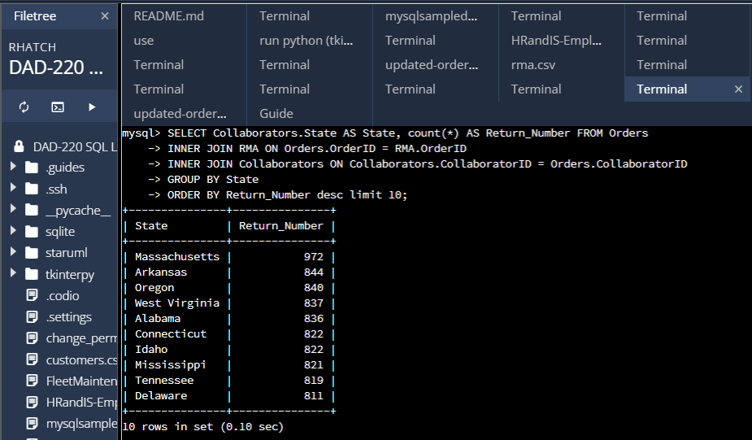  
     
   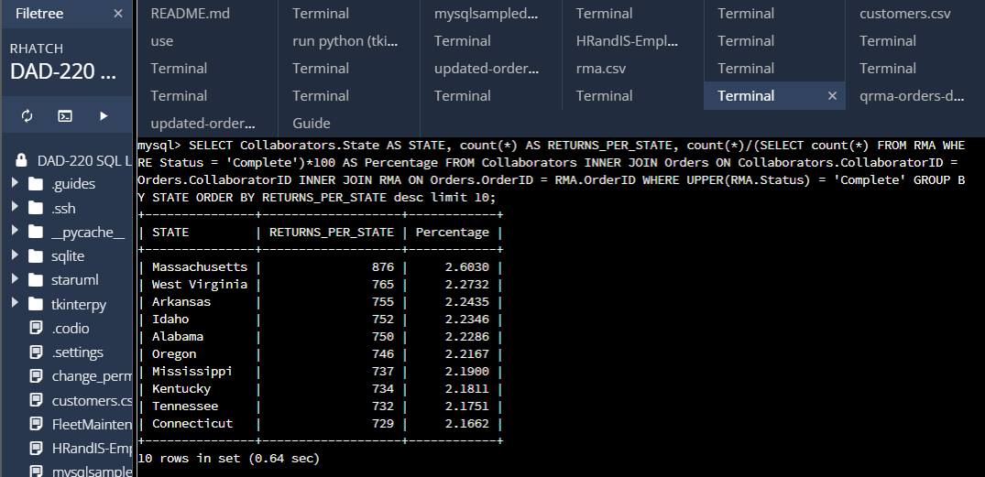

mysql> SELECT Collaborators.State AS STATE, count(*) AS RETURNS_PER_STATE, count(*)/(SELECT count(*) FROM RMA WHERE Status = 'Complete')*100 AS Percentage FROM Collaborators INNER JOIN Orders ON Collaborators.CollaboratorID = Orders.CollaboratorID INNER JOIN RMA ON Orders.OrderID = RMA.OrderID GROUP BY STATE ORDER BY RETURNS_PER_STATE desc limit 10;

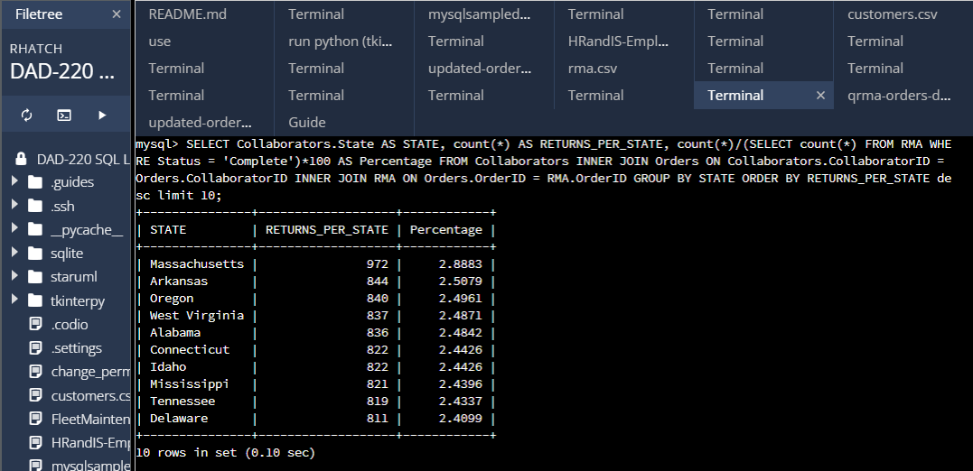

mysql> SELECT Collaborators.State AS STATE, count(*) AS RETURNS_PER_STATE, count(*)/(SELECT count(*) FROM RMA WHERE Status = 'Complete')*100 AS Percentage FROM Collaborators INNER JOIN Orders ON Collaborators.CollaboratorID = Orders.CollaboratorID INNER JOIN RMA ON Orders.OrderID = RMA.OrderID GROUP BY STATE ORDER BY RETURNS_PER_STATE desc limit 10;  
  
  
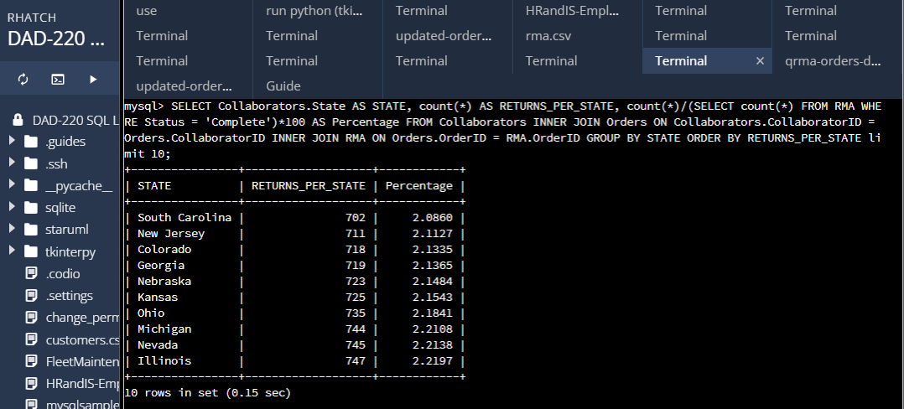

mysql> SELECT Collaborators.State AS STATE, count(*) AS RETURNS_PER_STATE, count(*)/(SELECT count(*) FROM RMA WHERE Status = 'Complete')*100 AS Percentage FROM Collaborators INNER JOIN Orders ON Collaborators.CollaboratorID = Orders.CollaboratorID INNER JOIN RMA ON Orders.OrderID = RMA.OrderID GROUP BY STATE ORDER BY RETURNS_PER_STATE limit 10;  
  
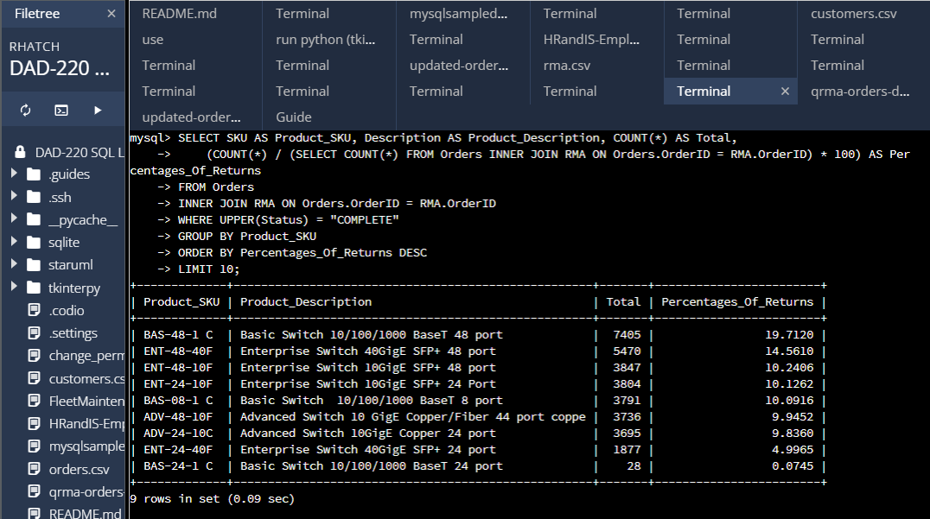

Analyze the percentage of returns by product type and describe your findings in your report:

Analyzing returns by state allows the product manager to identify regions with higher return rates. This information helps pinpoint potential issues related to product quality, customer experience, or shipping logistics in specific states. By focusing on these regions, targeted strategies can be implemented to address the underlying causes and improve customer satisfaction. The top 10 states with the highest number of returns were Massachusetts, Arkansas, Oregon, West Virginia, Alabama, Connecticut, Idaho, Mississippi, Tennessee, and Delaware. By allocating resources effectively and implementing quality control measures, the product manager can mitigate returns and improve customer support in these areas.

mysql> SELECT SKU AS Product_SKU, Description AS Product_Description, COUNT(*) AS Total,  
(COUNT(*) / (SELECT COUNT(*) FROM Orders INNER JOIN RMA ON Orders.OrderID = RMA.OrderID) * 100) AS Percentages_Of_Returns  
FROM Orders  
INNER JOIN RMA ON Orders.OrderID = RMA.OrderID  
WHERE UPPER(Status) = "COMPLETE"  
GROUP BY Product_SKU  
ORDER BY Percentages_Of_Returns DESC LIMIT 10;  
  
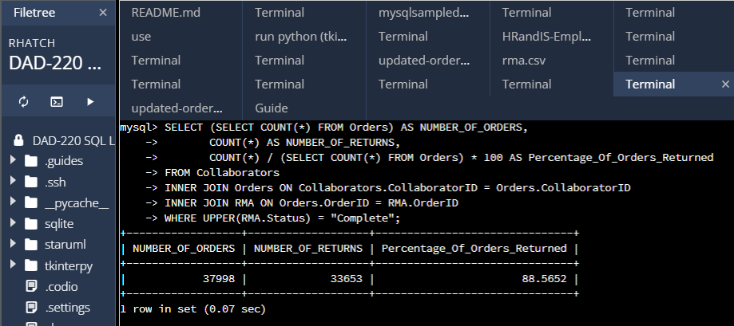

mysql> SELECT (SELECT COUNT(*) FROM Orders) AS NUMBER_OF_ORDERS,  
COUNT(*) AS NUMBER_OF_RETURNS,  
COUNT(*) / (SELECT COUNT(*) FROM Orders) * 100 AS Percentage_Of_Orders_Returned  
FROM Collaborators  
INNER JOIN Orders ON Collaborators.CollaboratorID = Orders.CollaboratorID  
INNER JOIN RMA ON Orders.OrderID = RMA.OrderID  
WHERE UPPER(RMA.Status) = "Complete";

1. In your report, clearly **summarize your analysis of the data for stakeholders**. Include screenshots of the results of each query. When summarizing results, you may want to consider the following questions: (25%)

**How does the data provide the product manager with usable information?**

The analysis of the return merchandise authorizations (RMAs) data provides valuable information for the product manager at Quantigration, enabling them to make informed decisions and take actions to optimize operations and enhance customer satisfaction.

The data analysis reveals key insights regarding returns by state and returns by product type. By analyzing returns by state, the product manager gains visibility into regions with higher return rates. This information is crucial for identifying potential issues related to product quality, shipping, or customer experience in specific states. By focusing on these regions, the product manager can allocate resources effectively, implement targeted quality control measures, and improve customer support to mitigate returns.

Moreover, the analysis of returns by product type helps the product manager identify specific products that have higher return rates. This insight allows them to investigate the underlying causes, such as product quality, design flaws, or customer dissatisfaction with specific features. By addressing these issues, the product manager can collaborate with the relevant teams to improve product design, manufacturing processes, or customer education, ultimately reducing returns and increasing customer satisfaction.

**What are the potential flaws in the data that has been presented?**

It is important to acknowledge the potential flaws in the presented data. Firstly, the analysis is based on completed RMAs and may not capture ongoing or canceled returns, which could provide additional insights. Secondly, the data does not provide information about the reasons for returns, making it challenging to identify the exact root causes. To overcome these limitations, it is recommended to conduct customer surveys, gather qualitative feedback, and incorporate data from customer support interactions to gain a more comprehensive understanding of the reasons behind returns.

**Are there any limitations on your conclusions, or any other ways of looking at it that you haven’t considered? Clearly communicate your findings to stakeholders.**

My analysis has provided me with some eye-opening insights that demand immediate attention. The data clearly shows that the number of returns is alarmingly high, and it's causing a significant financial strain on the company. In fact, the losses incurred through returns outweigh the revenue generated from sales, which is a concerning trend.

Given the gravity of the situation, the company needs to take swift action to address this issue. It's essential to reduce the rate of returns and minimize the financial losses associated with them. One way to gain a deeper understanding of the reasons behind returns is by tapping into additional data sources, such as customer feedback. This will provide Quantigration with valuable insights that can help us develop effective strategies to tackle the problem head-on. Additionally, conducting market research and analyzing Quantigration’s competitors can give us industry benchmarks and best practices that will guide us in improving our products, enhancing the overall customer experience, and streamlining our operations.

In conclusion, the analysis of the return merchandise authorizations (RMAs) data has revealed a critical and detrimental situation for the company. Returns are exerting a significant impact on the financial health, and if the company does not respond swiftly, it could jeopardize the long-term survival and even lead into bankruptcy and filing against chapter eleven.  
  
To turn things around, the company must prioritize actions that will reduce returns and improve the profitability. This entails addressing the root causes behind returns, whether it's related to product quality, customer experience, or other factors. It's imperative that all stakeholders come together, making informed decisions and taking decisive steps to optimize the operations, minimize the returns, and to restore and maintain financial stability within the company.